COURSE OVERVIEW
Welcome to the course!
This course will give you an introduction to spreadsheets – the kind you create on a computer, not paper. You’ll learn basic skills that you can use on the job, in your own business or in your life: how to create & format spreadsheets, how to use formulas & functions and how to create charts and graphs.

The focus is on practice! Lots of practice! Because you can learn anything if you put in the time and energy. Guaranteed.

Now a little about me!

I work at NSCC Online Learning. I work with spreadsheets every day -- mostly to track and analyze information. And I’ve been teaching people how to
use spreadsheets since the 1990s. (Don’t do the math!)

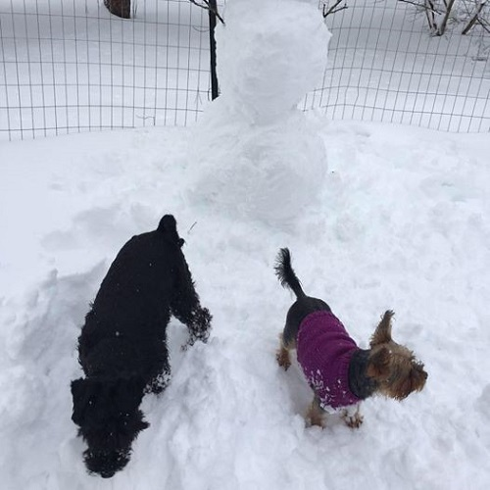
There are two things I’ve learned about spreadsheets. The first is that you never stop learning about spreadsheets. Just when you think you’ve mastered everything, you discover something new. The second thing is that anyone can learn to use spreadsheets. For some of us, it just takes a lot of practice, practice, practice! And this course is designed to help you do just that.

We’ve got lots to do! The next few weeks will be busy ones.

I live in the beautiful Annapolis valley with my husband and two puppies – Otto and Rosie. They love playing in the snow.

To get started
To start, read through the Welcome unit. Pay particular attention to our schedule and how you'll be evaluated.

